**DAILY ONLINE ACTIVITIES SUMMARY**

|  |  |  |  |  |  |  |  |  |
| --- | --- | --- | --- | --- | --- | --- | --- | --- |
| **Date:** | **24/06/2020** | | | | | **Name:** | **ASHISH GRACION MENEZES** | |
| **Sem & Sec** | **4&A** | | | | | **USN:** | **4AL18CS012** | |
| **Online Test Summary** | | | | | | | | |
| **Subject** | | **N/A** | | | | | | |
| **Max. Marks** | | **N/A** | | **Score** | | | **N/A** | |
| **Certification Course Summary** | | | | | | | | |
| **Course** | **MICROSOFT AZURE ESSENTIALS** | | | | | | | |
| **Certificate Provider** | | | **Great Learning** | | **Duration** | | | **12 hours** |
| **Coding Challenges** | | | | | | | | |
| **Problem Statement1:Write a java program to find the length of the linkedlist** | | | | | | | | |
| **Status:Executed** | | | | | | | | |
| **Uploaded the report in Github** | | | | | **YES** | | | |
| **If yes Repository name** | | | | | **https://github.com/ash7745/lockdown-coding** | | | |
| **Uploaded the report in slack** | | | | | **YES** | | | |

Online Test Details1: N/A

Certification Course Details: MICROSOFT AZURE ESSENTIALS(continuation)

Today I have completed 9 module each of duration 2,5,5,10,14,26,7,22,17,20 minutes

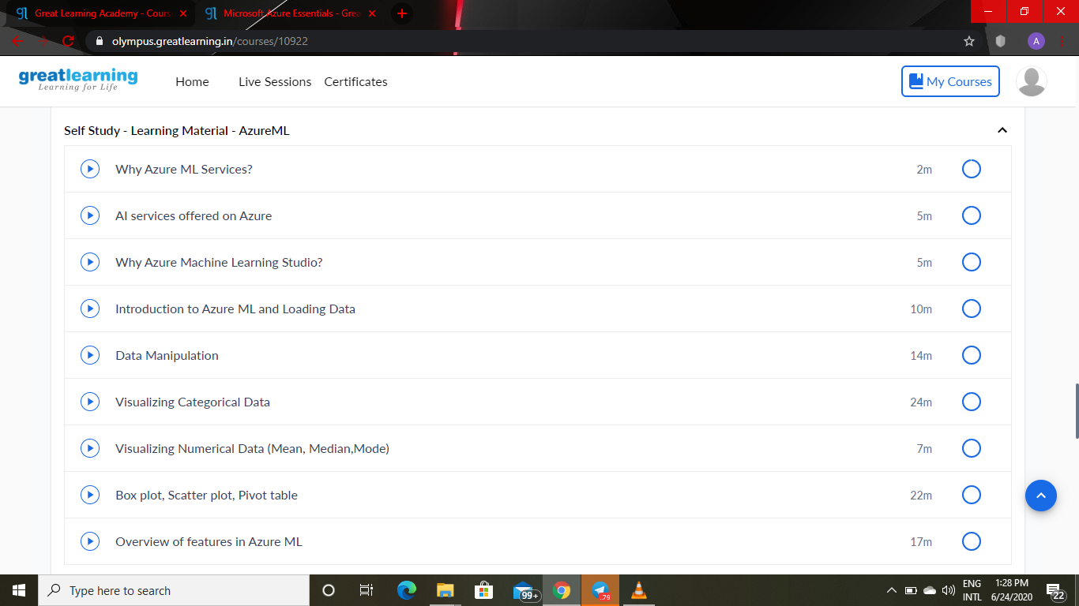

Webinar details: Webinar on C

Attended a session on C program(2:30pm to 4:00pm) which was organized by AIET Placement Department in Google meet and the session was conducted by Prof.Megha Hegde .The duration of the session was 1.5 hours. A quiz was conducted on the particular topic at the end of the session

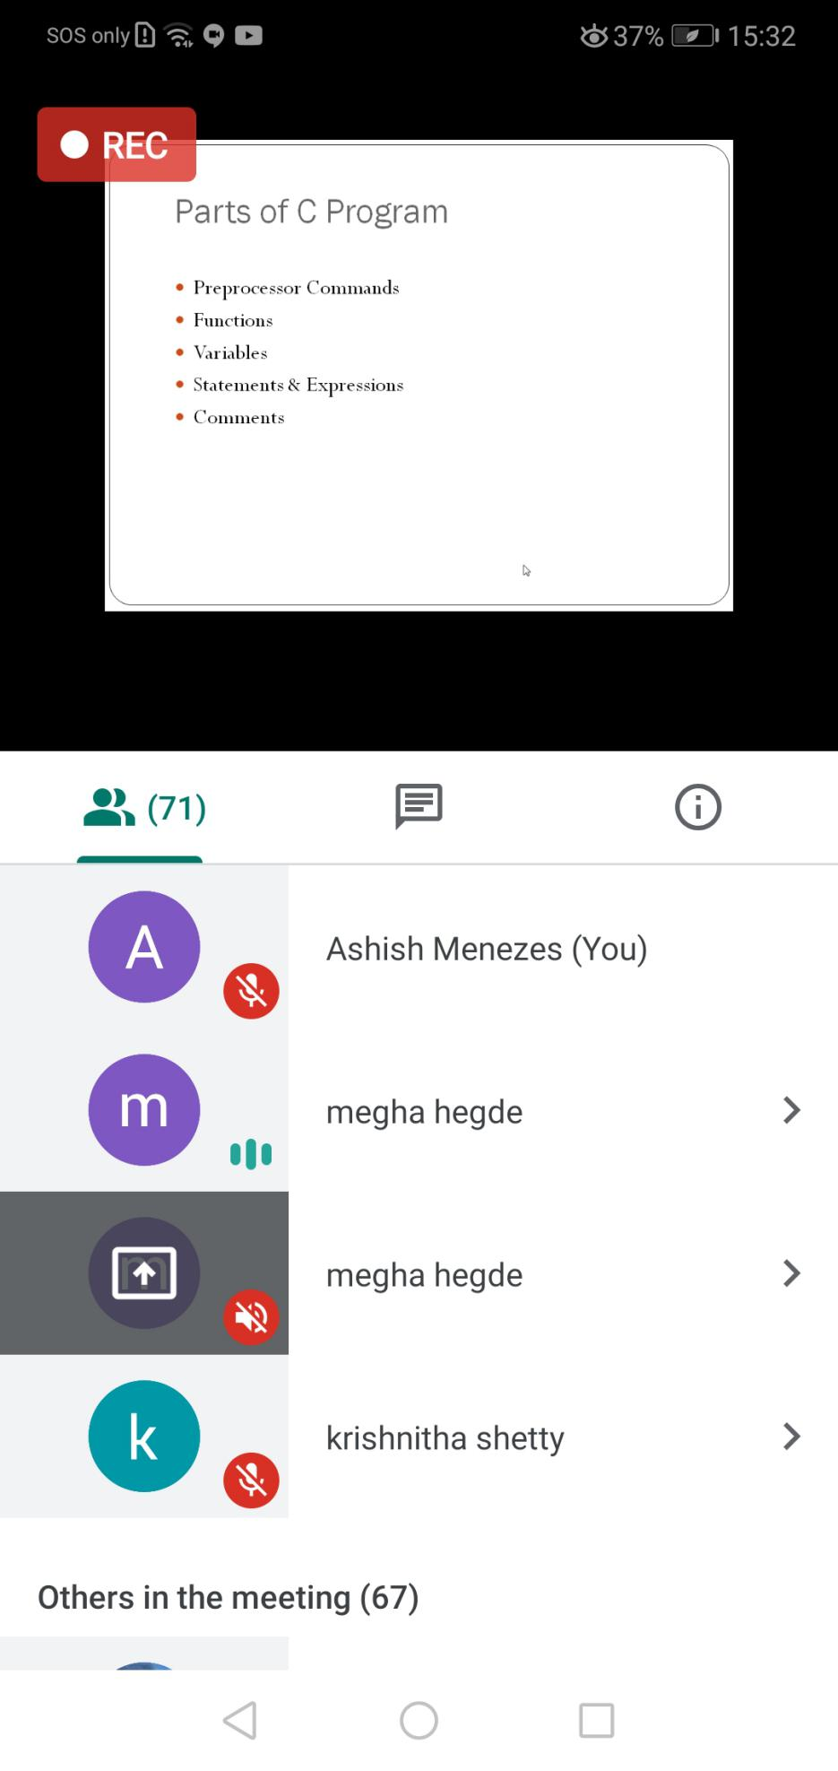

CODING DETAILS: Write a java program to find the length of the linkedlist

